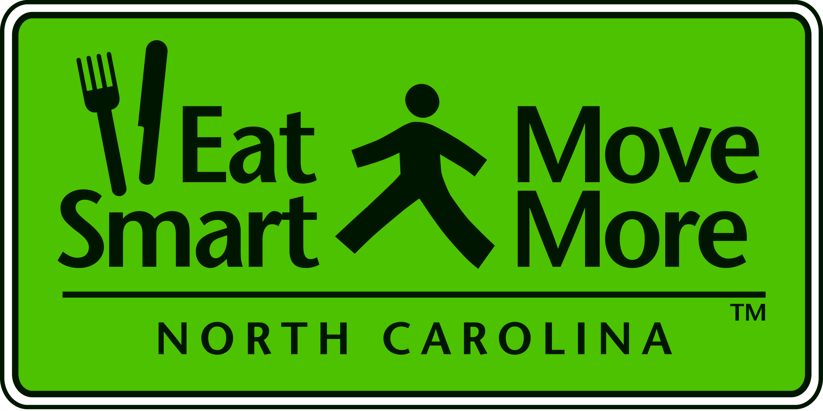
Eat Smart Move More, NC Leadership Team Meeting

December 1, 2011
1:00 – 3:30 p.m.
NC Medical Society Foundation

1:00 - 1:10 Welcome
Dr. Dave Gardner, Chair, Eat Smart, Move More NC

1:10 – 1:25 Update on the Development of North Carolina’s Obesity Prevention Plan 2013-2020
Dr. Carolyn Dunn, Past Chair, Eat Smart, Move More NC Chair, Prevention Plan Team

1:25 - 1:40 Update from the ESMM Policy Committee

Pam Seamans, ESMM Policy Committee Chair

1:40 - 1:50 Partnering to Create a Healthier North Carolina

Dr. Ruth Petersen, Section Chief, Chronic Disease and Injury Section, NC Division of Public Health

Libby Smith, Senior Policy Advisor for Community Development, Sustainability, ARRA Recovery & Assistant ARC Program Manager, NC Department of Commerce presented on the

Julie Hunkins, Manager, Quality Enhancement Unit, NC Department of Transportation

Lisa Riegel, Executive Director, Natural Heritage Trust Fund, NC Department of Environment and Natural Resources

Ben Hitchings, Planning Director, Town of Morrisville

Question and Answer

3:20 - 3:30 Closing Comments
Dr. Dave Gardner, Chair, Eat Smart, Move More NC

Bring a brown bag lunch and network with colleagues from 12:00 – 1:00 p .m. before all 2011 Leadership Team Meetings

Mark your Calendars – Our next quarterly meeting is March 14, 2012

