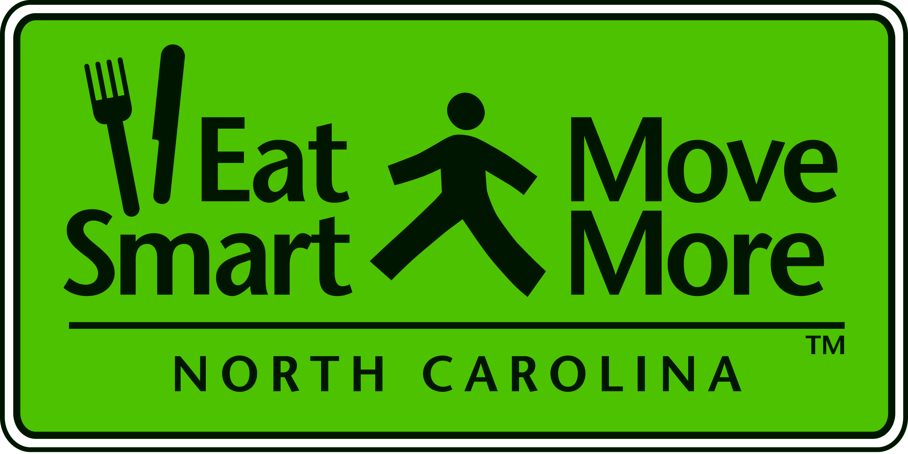
Eat Smart, Move More

Leadership Team Meeting

Monday, March 8, 2010
NC Medical Society

1:00 - 1:15 Welcome and Introductions
Carolyn Dunn, Chair, Eat Smart, Move More NC
NC Cooperative Extension

1:15 - 1:35 Legislative Task Force on Childhood Obesity Update
Co Chairs: Senator Bill Purcell MD
Representative Doug Yongue

1:35 - 1:50 ESMM LT Ad Hoc Committee Updates (5 minutes each)
Greg Griggs, Dave Gardner - Advocacy/Policy Committee
Lori Carter Edwards - Key Measures Committee

Jenni Albright - Surveillance Committee

1:50 - 2:30 Russ Pate, PhD, Chair
National Physical Activity Plan Coordinating Committee
University of South Carolina, Arnold School of Public Health

2:30 - 2:45 Questions and Answers

2:45 - 3:00 What Do These Recommendations Mean For NC?
Jimmy Newkirk, Physical Activity Coordinator
NC Division of Public Health

3:00 - 3:15 Questions and Answers

3:15 - 3:30 Closing Comments

2010 ESMM Leadership Team Meetings

Day | Date | Time | Location
Monday | June 14, 2010 | 1:00-3:30 | NCSU Arboretum
Monday | Sept 13, 2010 | 1:00-3:30 | TBD
Monday | Dec 13, 2010 | 1:00-3:30 | TBD

