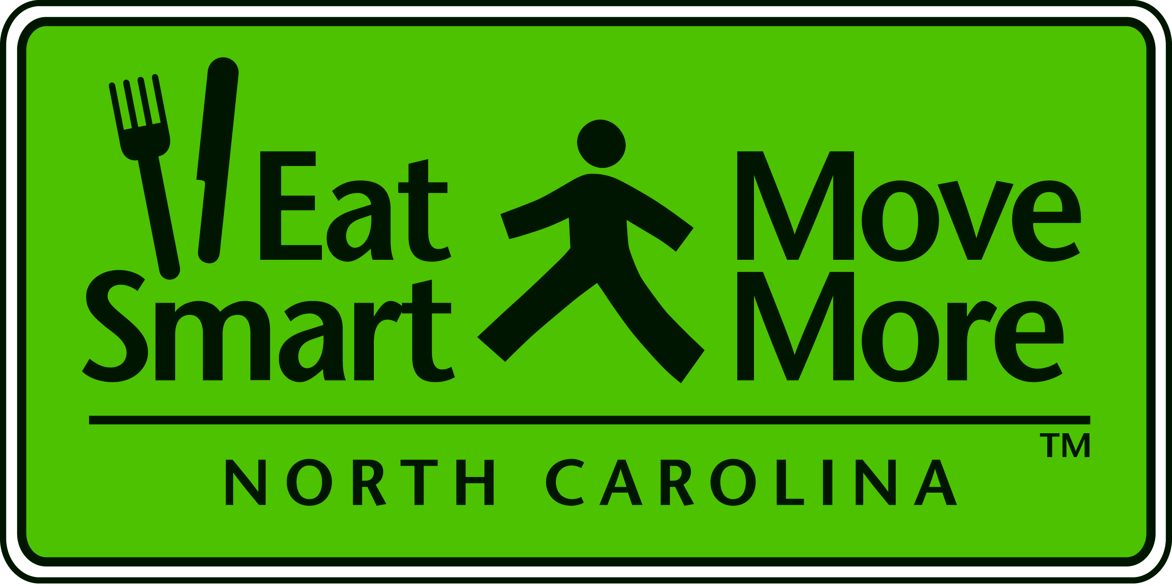
Eat Smart Move More Leadership Team Meeting

Monday, June 8, 2009
JC Raulston Arboretum
NC State University

1:00 - 1:30 Welcome and Introductions
Carolyn Dunn, Chair

Unveiling of ESMM NC: Your Road Map to Health
ESMM Progress Report

1:30 - 2:00 Prevention for the Health of North Carolina: An Interim Report of the NC IOM Task Force on Prevention
Presenting: Pam Silberman, President and CEO, NC Institute of Medicine

2:00 - 2:30 Farm to Fork: Building Sustainable Local Food

Presenting: Nancy Creamer, Professor of Horticultural Science and Director, Center for Environmental Farming Systems, NC State University

2:30 - 2:45 Eat Smart Move More Community Grants: Celebrating 10 Years of Funding for North Carolina Communities
Presenting: Mary Bea Kolbe, ESMM Community Grants Coordinator

2:45 - 3:00 Move More North Carolina: Recommended Standards for After-School Physical Activity
Presenting: Lori Schneider, Move More After-School Collaborative Coordinator

3:00 - 3:30 New Ad Hoc Committee Structure Carolyn Dunn, Chair

2009 ESMM Leadership Team Meetings
Day | Date | Time | Location
Monday | September 14 | 1p-3:30p | Alice Aycock Poe Center for Health Education - Raleigh
Monday | December 14 | 1p-3:30p | NC Medical Society  Raleigh

