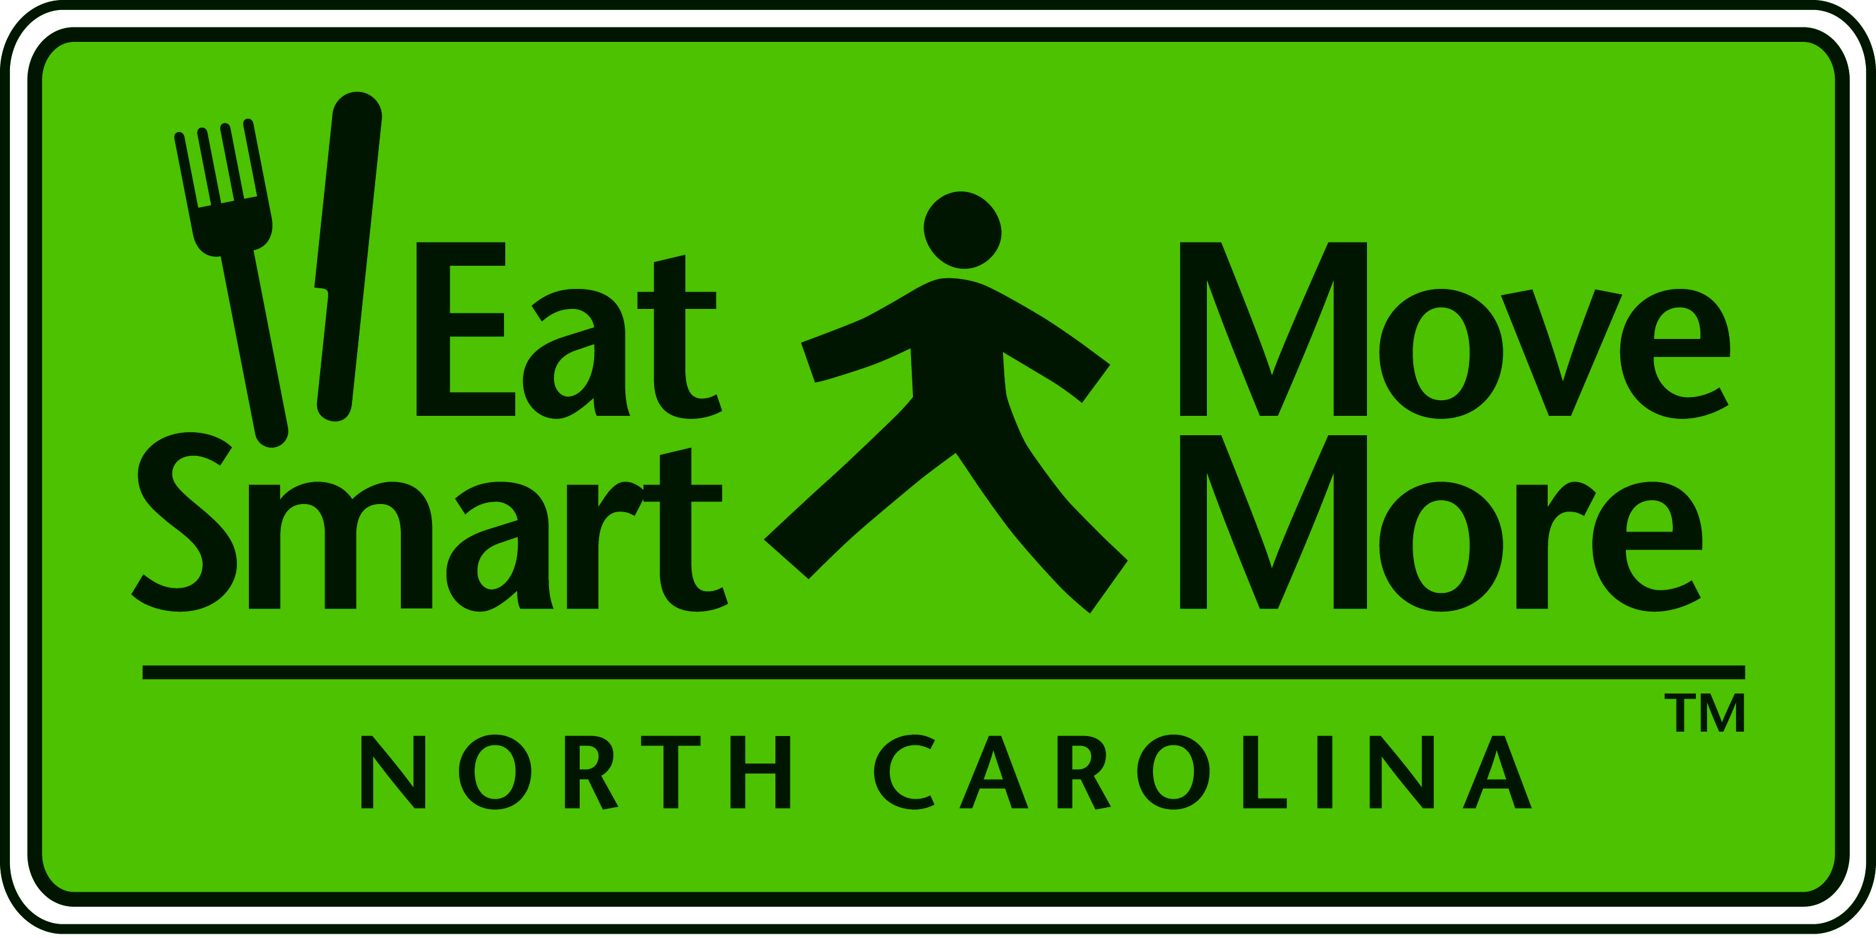
Eat Smart Move More Leadership Team Meeting

Monday, March 9, 2009

Wake Med Cary Hospital
Conference Center – Room B

1:00 - 1:15 Welcome and Introductions
Greg Griggs, Chair

1:15 - 1:55 A History of ESMM with New Bylaws and Proposed Slate
of ESMM Executive Committee Officers
Greg Griggs, Chair and Dr. Carolyn Dunn, Vice Chair

1:55 - 2:25 Review of NC Task Force on Preventing Childhood Obesity and NC Institute of Medicine’s Prevention Task Force Recommendations for Poor Nutrition and Physical Inactivity
Presenting: Dr. Ruth Petersen, Senior Public Health Advisor,
NC Division of Public Health

2:25 - 2:55 NCAAHPERD’s ISPOD - In School Prevention of Obesity and Disease Program
Presenting: Dr. Ron Morrow NCAAHPERD Executive Director & Judy Martino, Director of Special Programs

2:55 – 3:25 ESMM Implementation Survey Results
Presenting: Jenni Albright, Manager, Evaluation & Surveillance Unit, Physical Activity and Nutrition, NC Division
of Public Health

3:25 - 3:30 Closing Comments
Greg Griggs, Chair

2009 ESMM Leadership Team Meetings
Day | Date | Time | Location
Monday | June 8 | 1p-3:30p TBA | JC Raulston Arboretum NCSU
Monday | September 14 | 1p-3:30p TBA | TBA
Monday | December 14 | 1p-3:30p TBA | TBA

