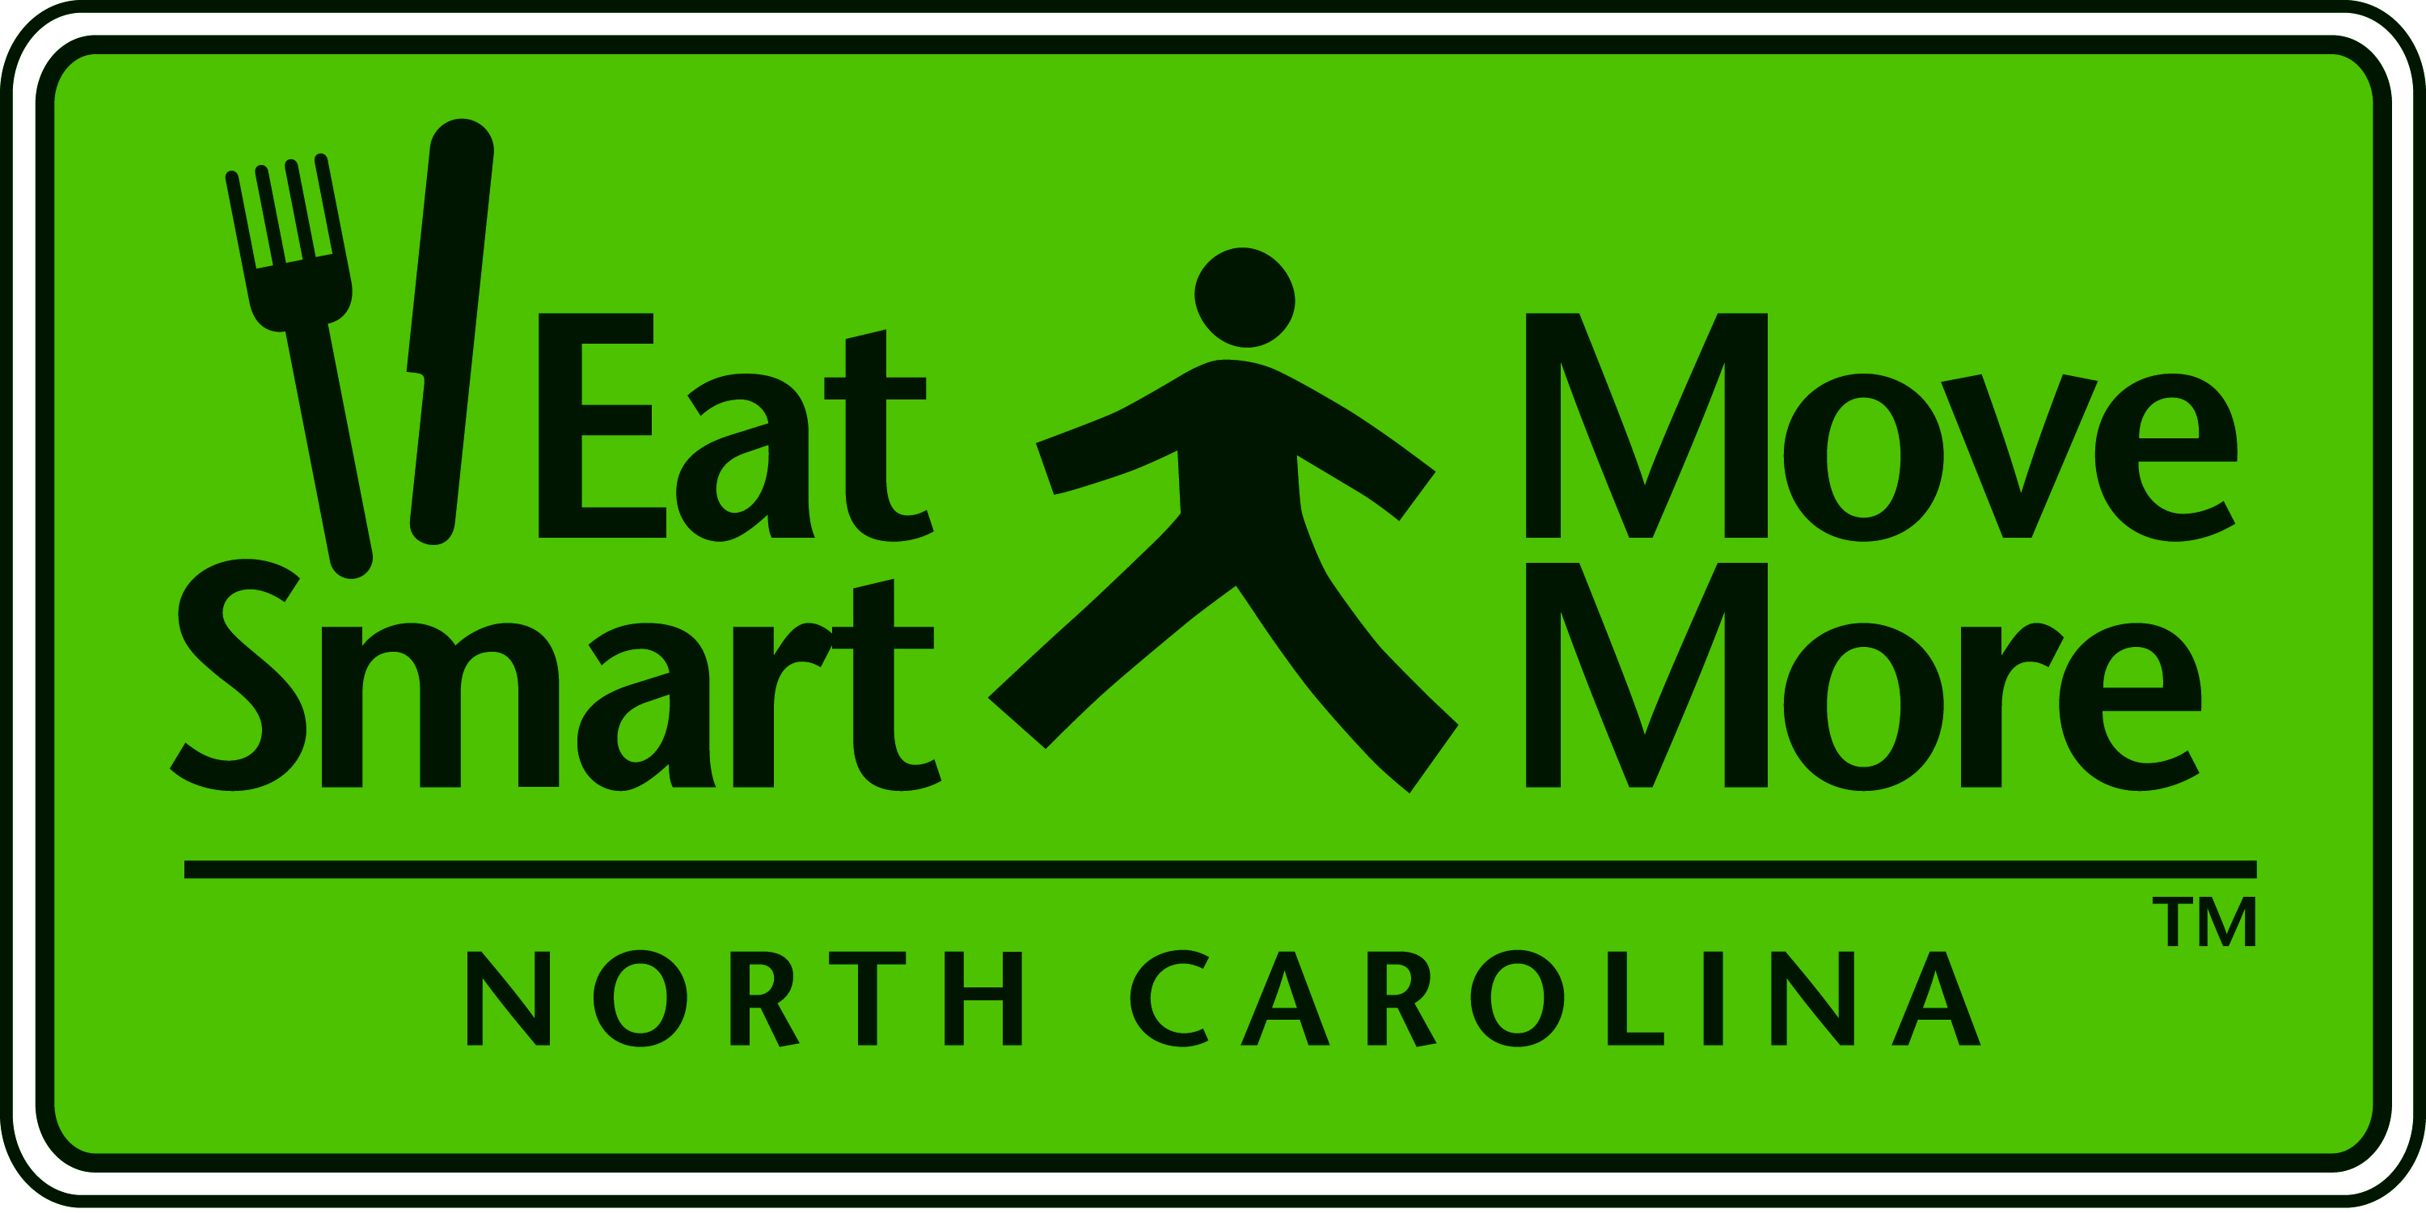
Eat Smart Move More Leadership Team Meeting

Monday, September 14, 2009
Wake Med Cary

1:00 - 1:20 Welcome and Introductions
Carolyn Dunn, Chair

1:20 - 1:35 ESMM LT Ad Hoc Committee Structure and Charges
Introductions of Committee Chairs

- Greg Griggs, Dave Gardner - Advocacy/Policy Committee Update
- Lori Carter Edwards - Key Measures Committee Update
- Jenni Albright - Surveillance Committee Update

Committee Members Announced

1:35 - 2:35 Stuffed: The Role of the Food Industry in

Obesity Prevention
Hank Cardello, Author of Stuffed

2:35 - 2:45 Questions and Answers

2:45 - 3:10 Partnerships Unite to Prevent Obesity
Sarah Kuester, CDC Project Officer for NC

3:10 - 3:30 Questions and Answers

2009 ESMM Leadership Team Meetings
Day | Date | Time | Location
Monday | December 14 | 1p-3:30p | NC Medical Society  Raleigh

