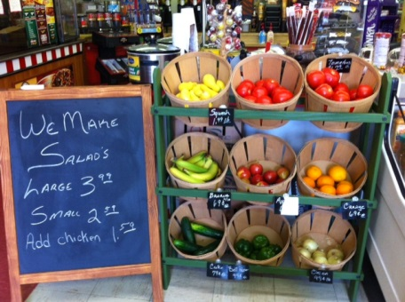

**Facts**

* Stocking healthy items can increase revenue for stores.
* Offering a variety of new products can help a business stand out and attract new customers.
* Healthy foods can yield high profit margins.

Example: 4 bags of chips = 20 cents profit vs. 1 apple = 20 cents profit

**Why Here and Now?**

* There is a **growing demand** for healthy, convenient, high-quality foods.
* Many children and their families get their food from convenience stores and need healthy food options to ensure they grow up strong and healthy.

**What Can Store Owners Do?**

Offer and promote healthy options to strengthen your store’s business and the health of the community.

**What Is the Next Step?**

To get involved or learn more, please contact:

______[Insert contact information]_______

[Insert your logo here]

**Why Do Healthy Options Matter in Small Food Stores?**

For communities without a nearby grocery store, small neighborhood stores are the most convenient locations for community members to shop for everyday food items. Many families want to buy healthy foods, but these items are hard to find.